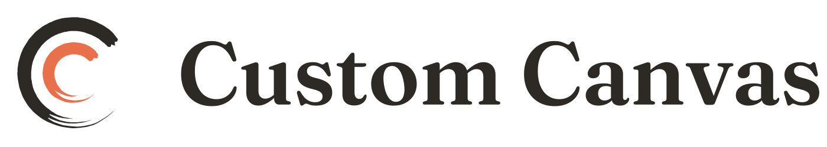
CUSTOM CANVAS
DMCA & Copyright Policy

APPLIES TO | Everyone
VERSION | 1.0
EFFECTIVE | September 3, 2026
ENTITY | Custom Canvas LLC, a Texas limited liability company
CONTACT | support@customcanvas.shop
How to send a copyright notice or counter-notice, and how repeat infringement is handled.

Our position
Custom Canvas respects copyright. Artists warrant that they own or control the rights to everything they list. We remove material we are properly notified is infringing, and we terminate repeat infringers.

Reporting infringement
Send a written notice to our designated agent containing all of the following. An incomplete notice may not trigger our obligations.
- Your physical or electronic signature.
- Identification of the copyrighted work you say is infringed.
- Identification of the material on Custom Canvas you say infringes, with enough detail for us to find it — a direct URL to the listing or profile.
- Your name, address, telephone number and email.
- A statement that you believe in good faith that the use is not authorized by the copyright owner, its agent, or the law.
- A statement that the information in your notice is accurate, and under penalty of perjury, that you are the owner or authorized to act for the owner.

Designated DMCA Agent
[NAME OR POSITION]
Custom Canvas LLC
3120 Southwest Freeway, Suite 101 #991985
Houston, Texas 77098
Telephone: [TELEPHONE NUMBER]
Email: [DEDICATED DMCA EMAIL]
Notices sent to this agent should relate to claimed copyright infringement under the Digital Millennium Copyright Act. Other legal notices, complaints, or customer-service requests should be sent to support@customcanvas.shop.
Misuse warning. Knowingly misrepresenting that material is infringing can make you liable for damages, including costs and legal fees, under 17 U.S.C. §512(f).

What we do on receiving a notice
When Custom Canvas receives a notice that substantially satisfies the DMCA's requirements, we may promptly remove or disable access to the identified material. We will take reasonable steps to notify the affected user and may provide that user with a copy or summary of the notice, including the claimant's contact information.
Custom Canvas may request clarification when a notice is incomplete, does not identify the material with reasonable specificity, or does not appear to concern copyright infringement.
Removal of material is not a determination that infringement occurred, and restoration of material is not a determination that the material is lawful.

Counter-notice
If your work was removed and you believe that was a mistake or misidentification, send a counter-notice containing:
- Your physical or electronic signature.
- Identification of the removed material and where it appeared.
- A statement under penalty of perjury that you believe in good faith it was removed as a result of mistake or misidentification.
- Your name, address and telephone number, and a statement consenting to the jurisdiction of the federal court for your district (or, if outside the US, any district where we may be found), and that you will accept service from the person who gave the original notice.

By submitting a counter-notice, you acknowledge that it may be forwarded to the person who submitted the original notice.
If Custom Canvas receives a substantially compliant counter-notice, we will forward it to the original claimant. Custom Canvas may restore the material not less than 10 and not more than 14 business days after receiving the counter-notice unless the designated agent first receives notice that the claimant filed a qualifying court action seeking to restrain the alleged infringement.
Custom Canvas may decline restoration when the material independently violates the Terms of Service, Listing Standards, or applicable law.

Repeat infringers
Custom Canvas terminates, in appropriate circumstances, the accounts of users who repeatedly infringe the copyrights of others.
We assess repeat infringement on the total circumstances rather than a fixed count. Relevant factors include the number of substantially compliant notices concerning a user, whether a counter-notice was filed and accepted, whether a notice was withdrawn or plainly defective, the volume and nature of the material, whether the user was previously warned, whether the conduct appears deliberate or commercial in scale, and whether the user cooperated in removing the material.
As general guidance, three or more substantiated notices within twelve months will ordinarily result in termination. A notice is ordinarily not counted where the user files a counter-notice that we accept, where the notice is withdrawn, or where the notice is plainly defective.
Custom Canvas may terminate an account immediately, without regard to the number of prior notices, for deliberate or large-scale infringement, such as wholesale copying of another artist's catalog, or where termination is required by law.
Custom Canvas may also take action short of termination, including removing material, restricting listing privileges, issuing a warning, or suspending an account while a matter is reviewed.
Nothing in this section limits Custom Canvas's right to remove content or close an account for any other violation of the Terms of Service, the Artist Agreement, or the Listing Standards.

Not a substitute for the Listing Standards
A DMCA notice addresses copyright: who owns an image. Claims that a work is forged, misattributed or misdescribed address whether a piece is what it claims to be, and are handled under the Listing Standards. Different problem, different process.
Questions: support@customcanvas.shop

